MyDog Virtual Assistant

Osvaldo Sanchez, Joshua Toth, Nicholas Mueth, Parfait Domagni

Southeast Missouri State University

Table of Contents

Problem Statement 4

Functional Requirements 4

Nonfunctional Requirements 4

Analysis 5

Scenarios: 5

Business Model 5

Entity-Relationship Diagram 9

Design 9

Goals 9

Performance Criteria 10

Initial Interface Design 10

Home Page 11

Clicked Disease 12

Disease Page 13

Tips and Tricks Page 14

Symptoms Page 15

About Page 16

Interface Specifications/Communication Diagram 17

Component Diagram 18

Deployment Diagram 19

Restructuring to Manipulate the System Model 19

Persistent Data: 19

Global Control Flow 20

Identify Off-The-Shelf Components: 20

Implementation 21

Symptoms 22

Diseases 25

Clicked Diseases 25

Tips and Tricks Page 27

About 27

Database 29

Conclusion 29

User Manual 30

I just got a new dog, could you tell me more about it? 30

My dog is sick! I know the symptoms, but want to know what could be wrong. 30

I think I know the disease my dog has, but I want to know more about it. 30

I want to be a better dog owner. 30

I want to learn more about this site’s creation. 30

Administration Manual 31

Glossary 31

Conclusion 32

Appendix A – Client Acceptance Form: 32

Appendix B – Interfaces and Code Snippets: 34

Interfaces 34

Home Page Interface 34

Symptoms Page Interface 34

Results Page Interface 36

Disease Page Interface 37

Tips and Tricks Page Interface 37

Code Snippets 37

Appendix C - Communication: 43

Contribution List 47

Osvaldo Sanchez 47

Joshua Toth 47

Nick Mueth 47

Parfait Domagni 48

Files 48

# Problem Statement

We are tasked with creating a virtual assistant for dogs. The goal of this virtual assistant is to create an easy-to-use and simple to understand interface that helps users find information surrounding potential diseases and health conditions affecting their dog. General health advice and tips for dogs will also be provided. However, as no members are actual licensed veterinarians, the information will be attained through credible sources with a disclaimer to seek professional help if necessary. Appropriate citations of information and disclaimers will be added as necessary.

# Functional Requirements

* Will run on all major browsers
* Will run without the need for the user to create an account
* Will be easy to use and will not require user to read user manual
* Needs to be clear and concise in providing information
* Will properly point to the diseases or problems that might ail the dog
* Will distinguish self as not to be used in making life threatening decisions pertaining to the health of the dog
* Will need to be able to take over unnecessary traffic influx to veterinarian offices
* Will need to be able to assist in even the smallest of cases
* Will need to allow updates to the database and UI

# Nonfunctional Requirements

* **Reliable**
  + Users can consistently find the proper information they need
* **Performance**
  + Lightweight and fast
* **Flexible**
  + Able to adapt to user’s needs
* **Visual**
  + Easy to navigate

# Analysis

## Scenarios:

**Scenario 1-** A new dog owner wants to find out how to properly take care of their new pet. They find our website through a Google search and navigate to our “Tips and Tricks” page to find relevant information about dog health.

**Scenario 2-** A user finds the page through word of mouth and navigates through it. They are searching for information about symptoms their dog is having, including a loss of appetite and sneezing. By going through our symptoms page, they can find relevant diseases and ailments, as well as information to help their pet.

**Scenario 3-** An older user receives a pug as a gift and wants to know about health conditions they may face, knowing their breed is more vulnerable to certain diseases and genetic defects. By landing on our home page, they find basic information about their breed and gain knowledge about how to take care of them. They can navigate through our homepage easily, with the majority of reading material written in a simple and digestible manner. The rest of the site’s navigation is done mostly through large images and large text.

## Business Model

**Use case actors:**

* End User: Uses the web application, owns a dog with an illness, is looking to get a dog, is looking for ways to improve the knowledge they have of their dog
* MyDog Virtual Assistant: Provides information for the End User, attempts to solve the problem of what is ailing the dog based on the knowledge inputted by the End User, attempts to educate the End User in the area of dog knowledge.

**End User Use Case:**

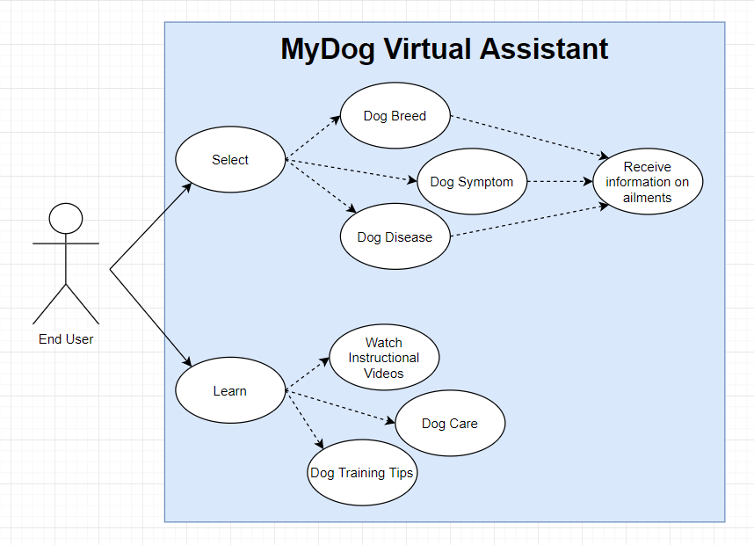

* **Select**
  + End User makes a selection from the home page
    - Dog breed:
      * End User selects based on the dog breed
    - Dog Symptom:
      * End User selects based on the symptoms the dog is experiencing
    - Dog Disease:
      * End User selects based on the disease they believe the dog has
  + Receive information on ailments:
    - MyDog Virtual Assistant uses the information provided to attempt to make a prediction regarding what the dog may be suffering from and then provide resources to help the End User determine the steps to take to ensure the dog returns to better health.
    - health.
* **Learn**
  + End User goes to the learn section of the page
    - Watch instructional videos:
      * End User can select from library of instructional videos to watch
    - Dog Care
      * End User can read up on dog care tips, such as bathing dogs, feeding dogs, etc.
    - Dog Training Tips
      * End User can read up on dog training tips, such as teachings dog not to bite, how to sit and stay, obedience commands, how to avoid making messes in the house, etc.

**MyDog Virtual Assistant Use Case:**

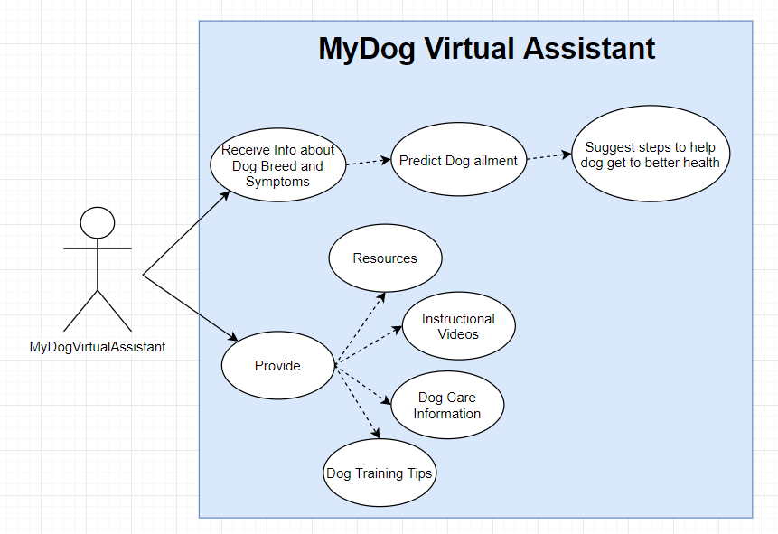

* **Receive info about dog breed and symptoms:**
  + MyDog Virtual Assistant receives information from the end user concerning the dog breed and symptoms it is experiencing
    - Predict Dog Ailment
      * MyDog Virtual Assistant predicts whatever disease or ailment is affecting the dog
  + Suggest steps to help dog get to improve health
    - MyDog uses the information and its prediction to provide resources to attempt to ensure dog returns to good health.
* **Provide**
  + MyDog Virtual Assistant provides the following information to End User
    - Resources about dogs
    - Instructional videos about dog care and training
    - Dog care tips, such as bathing and feeding dogs, etc.
    - Dog training tips, including obedience commands, how to sit and stay, and how not to make a mess in the house.

## Entity-Relationship Diagram

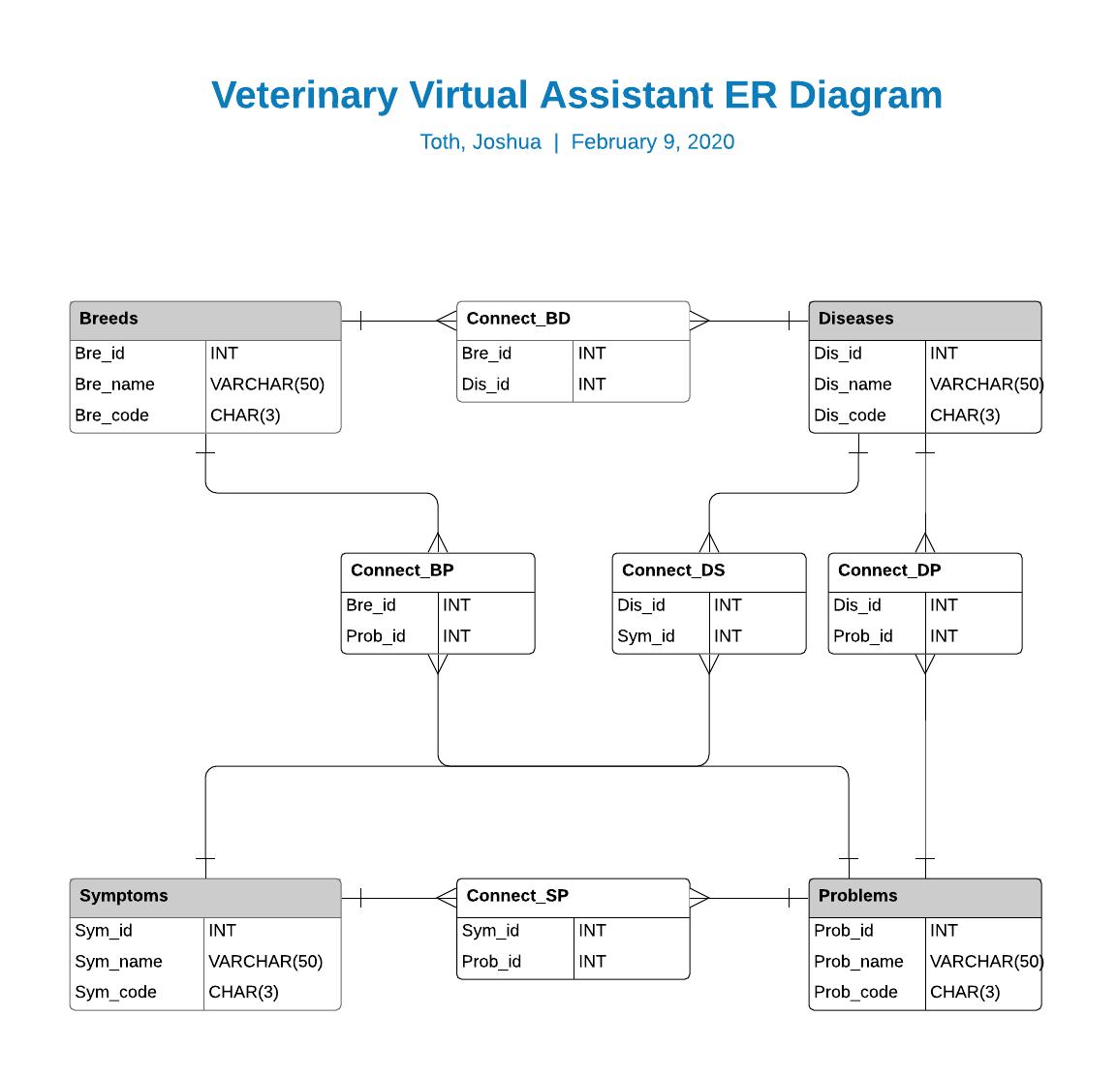

# Design

## Goals

**Easy to Navigate-** The user should be able to look at their page and instantly know how to use it

**Simple data types that need transference-** There is no complex data that needs to be manipulated, therefore search is fast and easy

**Database acts as the workhorse-** This design is largely database dependent when it comes to search functions

**Limited Text-** Very visual design that only uses text when necessary

**Visual Text-** When text is used, it is easy to read and to process, like it is, itself, an image

**Clean and modern look-** No clutter or complex visuals, but the color and overall layout should be high quality

## Performance Criteria

**Runs efficiently and seamlessly**- The software will run at an efficient speed, loading times will remain low. Transitioning between activities and pages on the software will be smooth and not jarring.

**Resource Light**- The software is low on resource intake. Animations are kept to a minimum and only used when necessary. Unnecessary resources that bog down page performance are kept to a minimum. Resource loads on the web server are also kept low.

**Software doesn’t contain errors**- Nearly all errors, especially major bugs, are fixed and patched before release, with appropriate updates being installed and history kept up to date.

**Software runs under expected conditions and beyond**- Software runs on all major browsers and at a higher than efficient speed.

**Software operates consistently on all pages**- The performance of the software is consistent across all pages. The aim is to have all pages run at almost the same level in terms of performance.

# Initial Interface Design

## Home Page

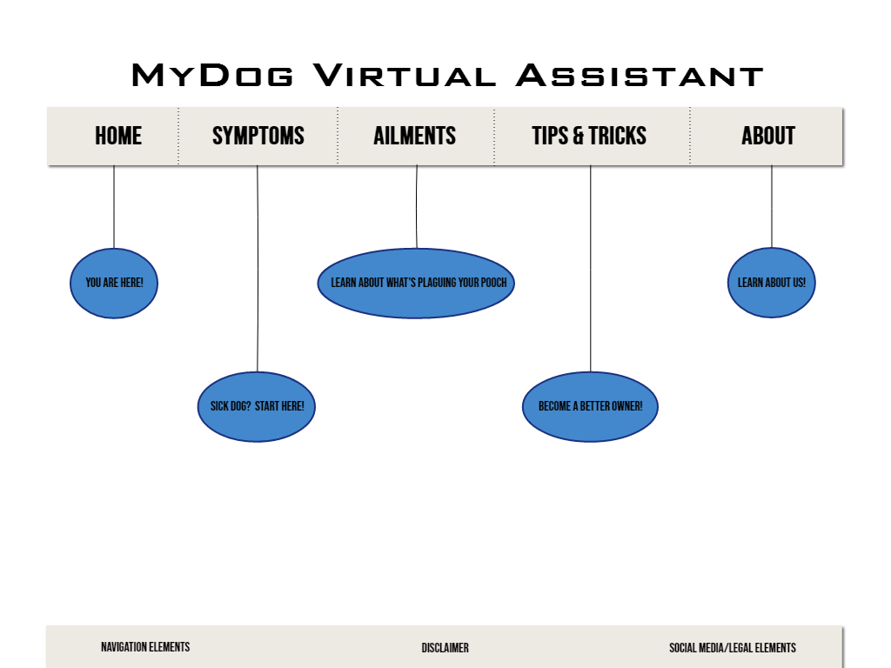

## Clicked Disease

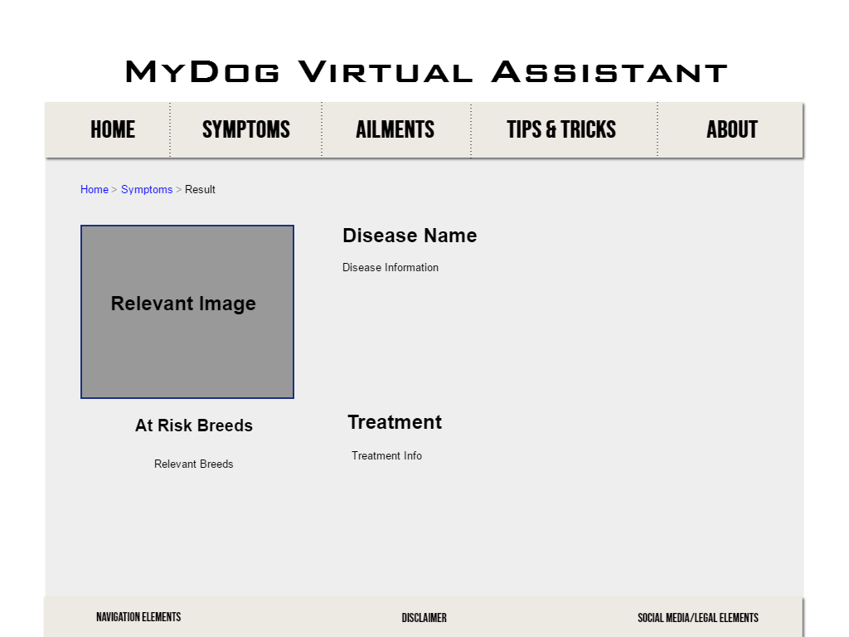

## Disease Page

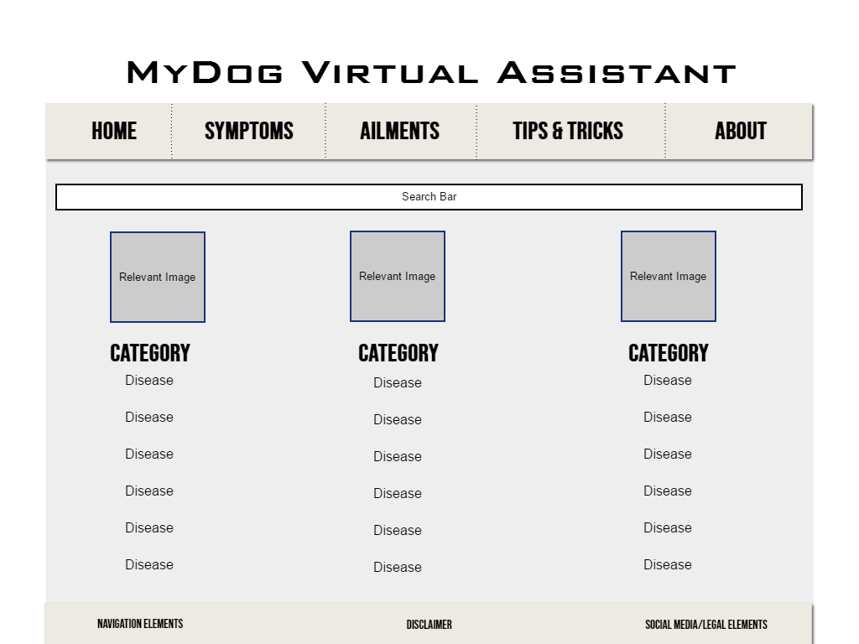

## Tips and Tricks Page

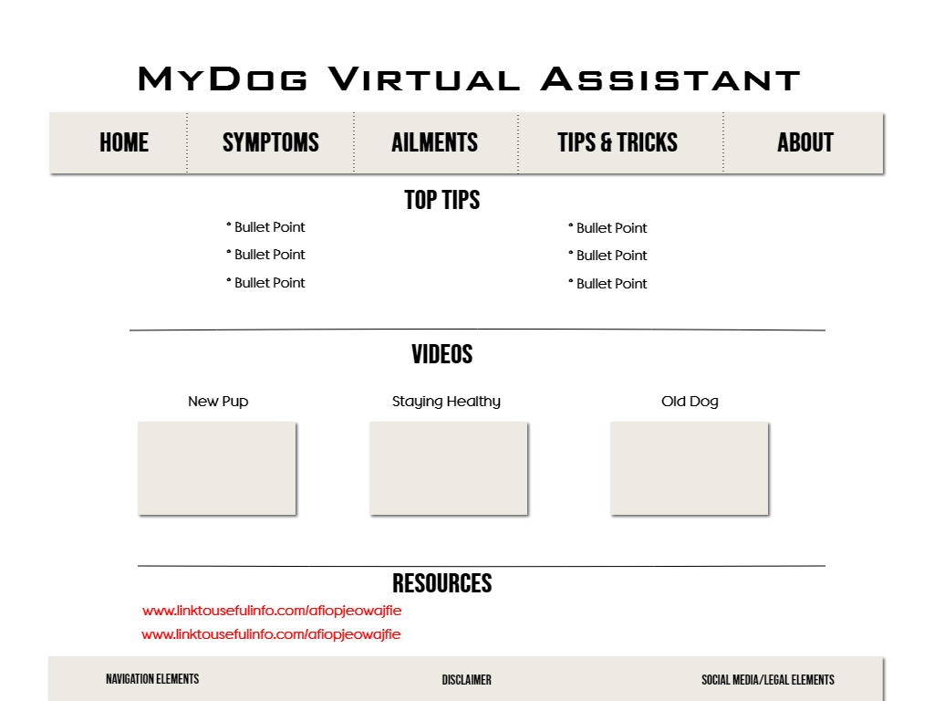

## Symptoms Page

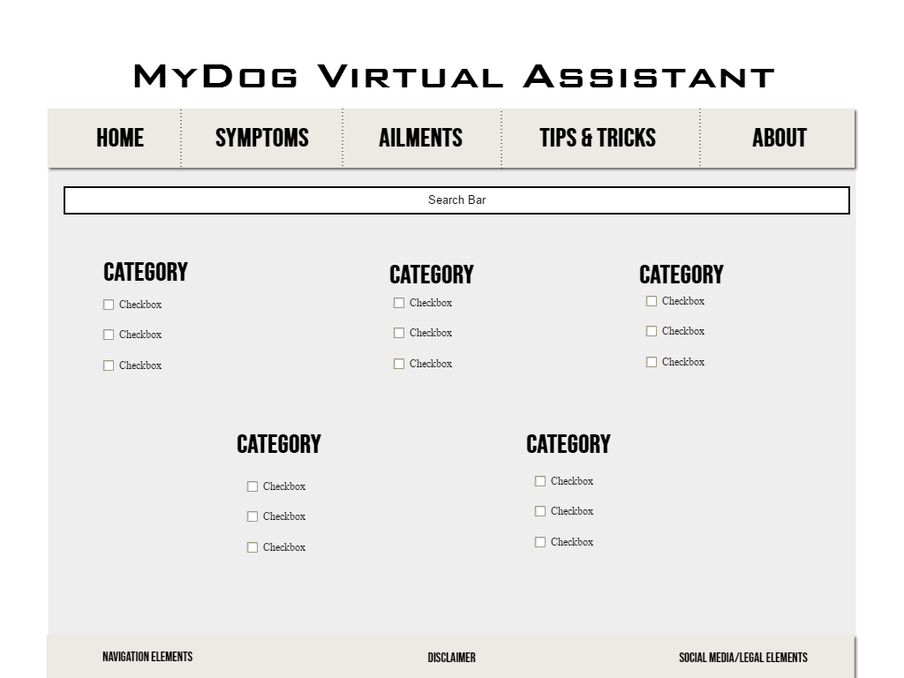

## About Page

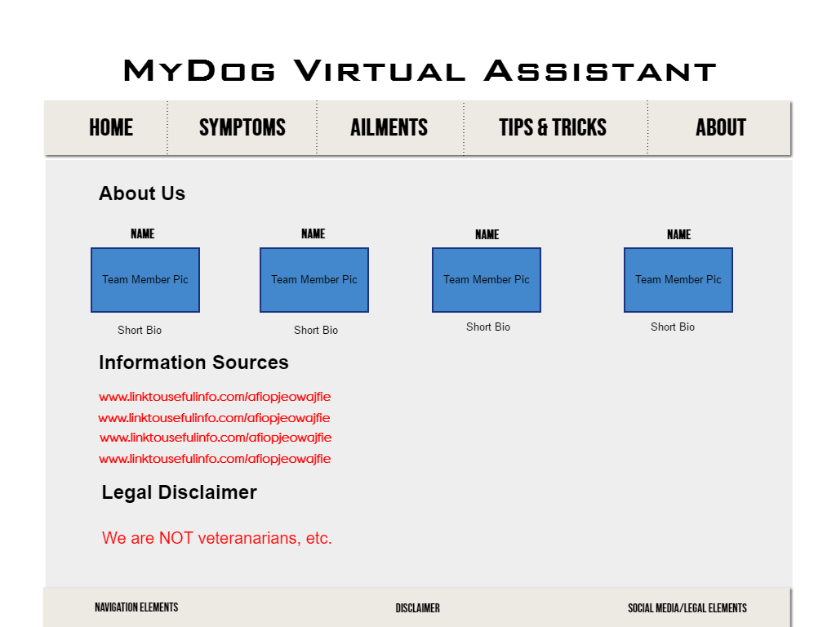

## Interface Specifications/Communication Diagram

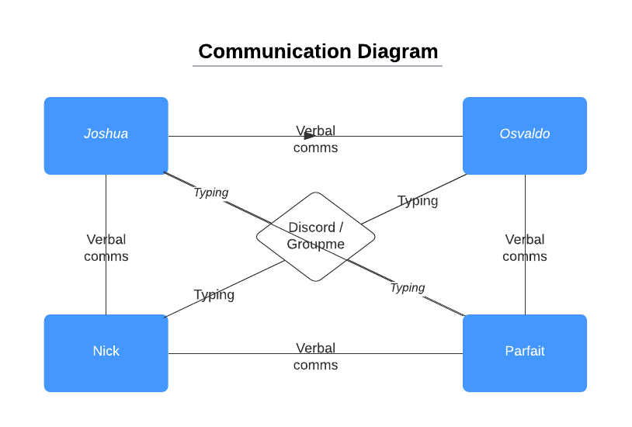

## Component Diagram

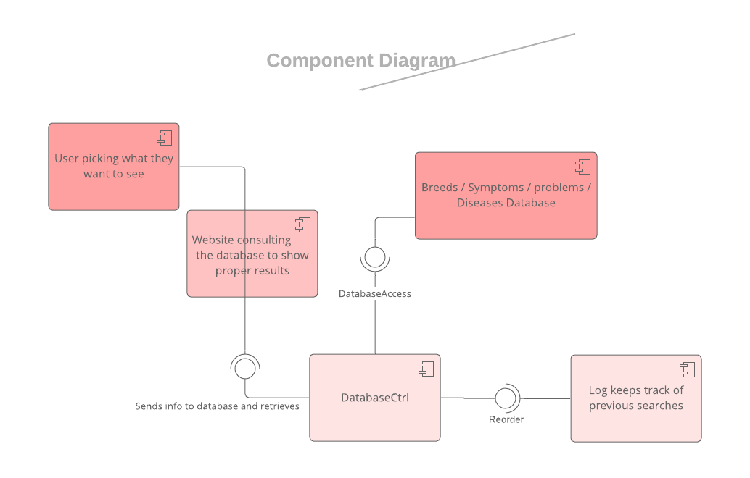

## Deployment Diagram

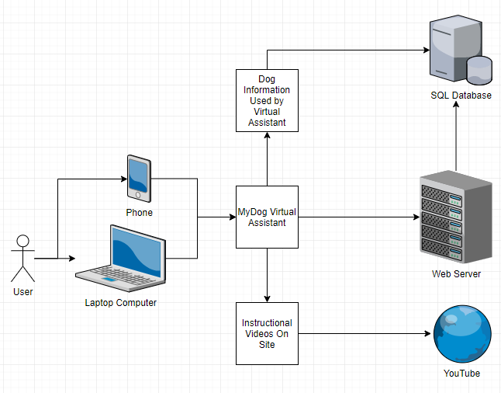

## Restructuring to Manipulate the System Model

An appropriate color scheme and font will be designated to the web app so that the same elements can be used for a visually consistent design and so the CSS files do not get overly complicated. We will focus on using the same navigation bar and the same footer across all pages. These will be components that can be reused across every single page. Pages which will need to be populated with relevant information will act as templates. The information within them will be taken from a database. This will help reduce coding times by having them already be built, like a template for our own pages.

## Persistent Data:

In our case this is the Code related to each subset of data examples such as, Breed_ID for instance. Although this piece of information is not accessed often, it is still key in the representation of the data schema.

## Global Control Flow

The MyDog Virtual Assistant will implement an Event-Driven Control Flow. When an event is triggered, whether it be someone clicking something on a page, entering information about the symptoms of their dog, clicking a hyperlink, etc., the software will trigger a change in view or something to carry out the desired action. We decided on this flow because it suits our needs as something based in graphic design interfaces and is flexible to work with. Since our software will be Web based, it does not need to rely on threads or procedures like other control flows might need.

Identify Services:

* Visual Studio Code – IDE + Debugger
* Google Chrome – Browser + Debugging
* GitHub – Code Repository
* MySQL workbench - Database Management
* GroupMe and Discord for communication
* WAMP – Local PHP and MySQL Server

Information Sources:

* [https://www.vcahospitals.com](%20https://www.vcahospitals.com) – Main source of information
* <https://www.merckvetmanual.com> – Secondary source of information
* <https://www.wagwalking.com> – Tertiary source of information

Image Sources:

* <https://www.pixabay.com> – Main source of images
* <https://www.pexels.com> – Secondary source of images
* <https://www.unsplash.com> – Tertiary source of images
* <https://www.vcahospitals.com> – Sparse Images used where most appropriate

## Identify Off-The-Shelf Components:

* Bootstrap
* jQuery
* Webkit

Languages used:

* HTML
* CSS
* PHP
* SQL

# Implementation

Our implementation has gone well, and we have stayed the course using our design layouts originally created by Osvaldo. Many of them were taken as concepts and have been refined into our nearly final products. Now, we have the designs of all pages 90% completed and ran into some unexpected bugs with conflicting stylings and database issues.

All navigation is functional. It is mostly database queries and further design refinement that requires polishing.

Most pages were originally designed by Osvaldo Sanchez in tandem with relevant group members. Implementation is credited by page, with Nick Mueth being the main driving force and most knowledgeable group member behind most pages in terms of HTML and CSS. The database was largely created by Joshua Toth, whose focus has been the backend while Osvaldo and Nick have focused on the development of the websites. Parfait Domagni contributed to the reporting and presenting in the early development phases.

Home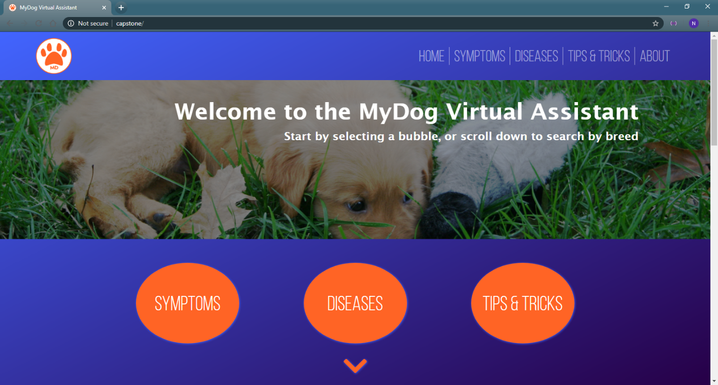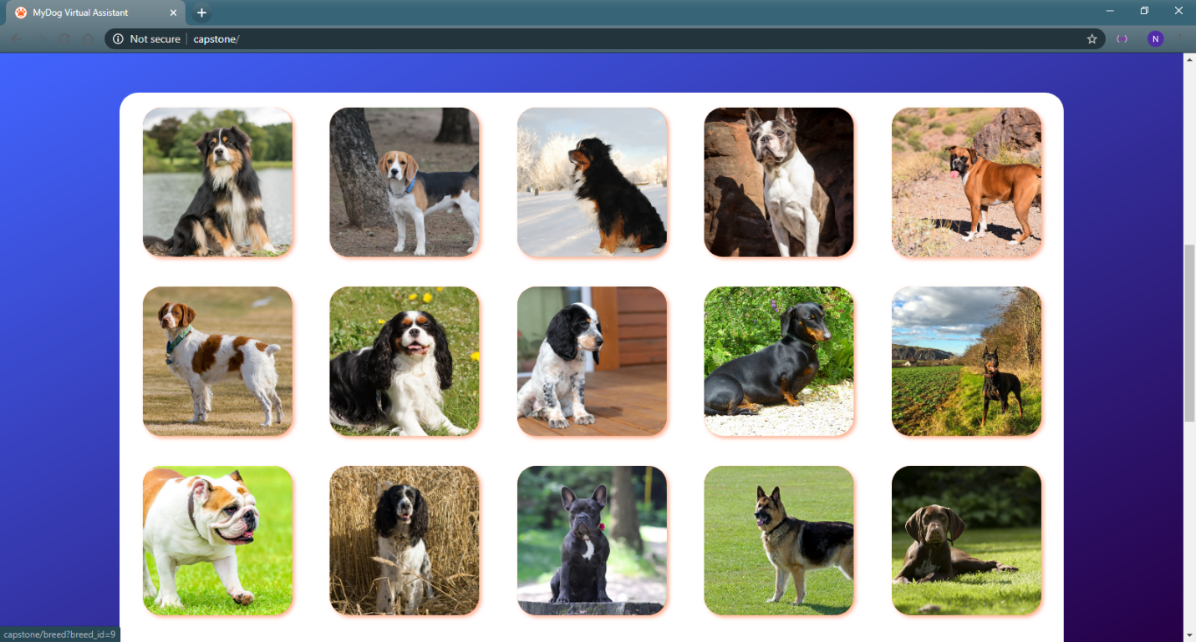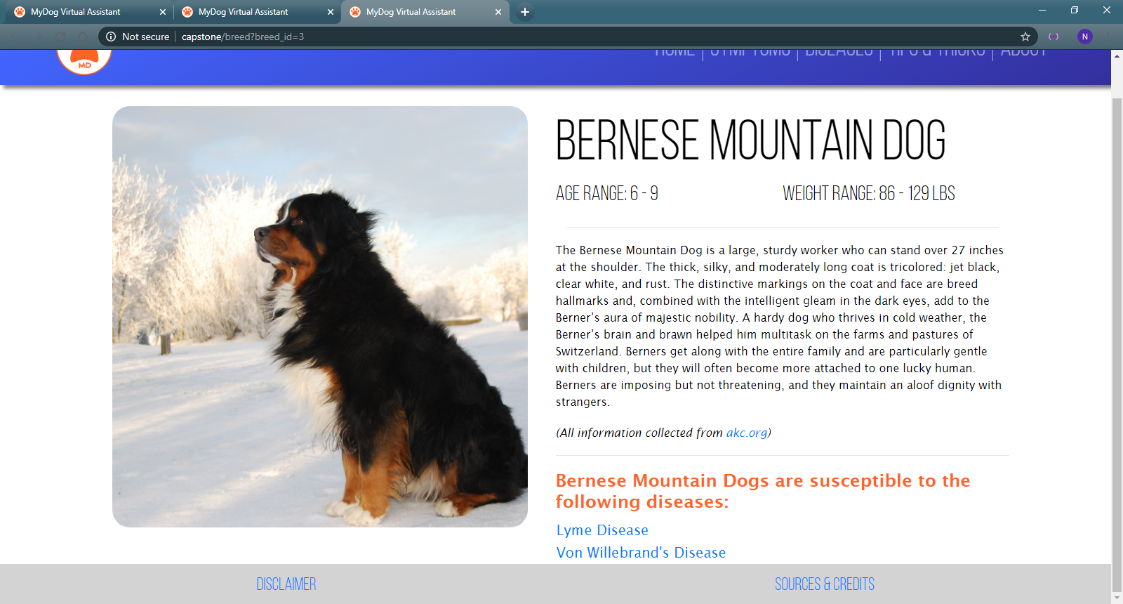

Our home page was conceptualized between Nick Mueth and Osvaldo Sanchez. Implementation by Nick Mueth.

This is the landing page for users. They are presented with a navigation bar at the top if they have a specific page in mind. If not, they can scroll down and find information about the breed of their dog.

## Symptoms

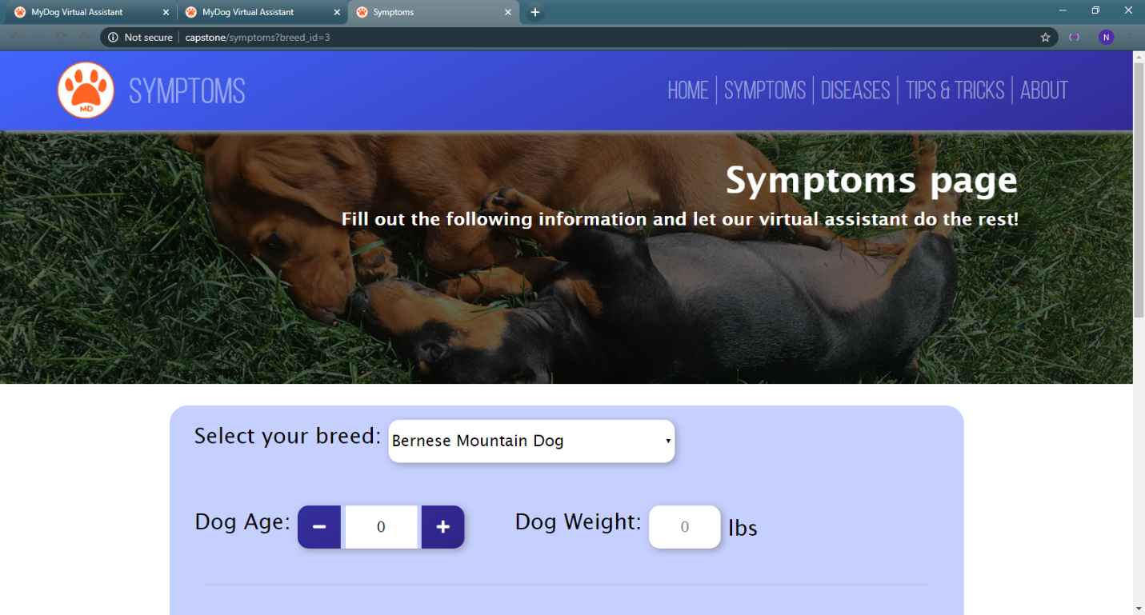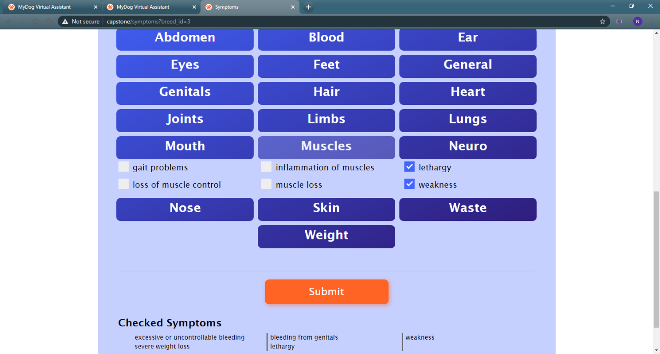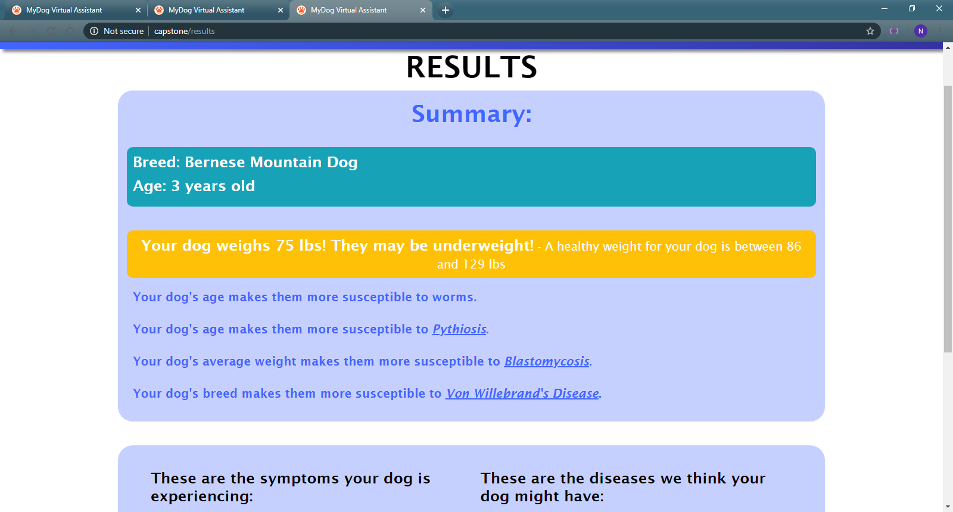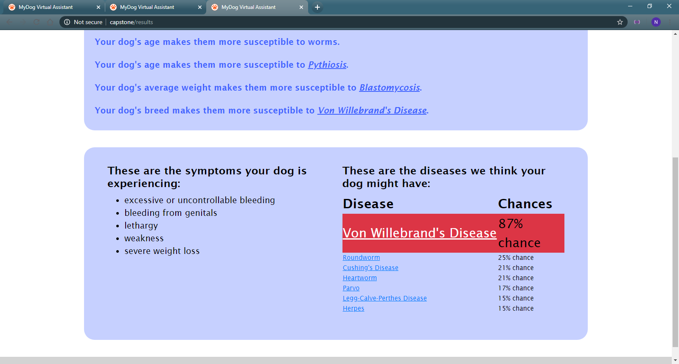

Page conceptualized and implemented by Nick Mueth and Joshua Toth.

Our symptoms page is one wherein the user can select which symptoms their dog is experiencing. A predictor will return valuable information to them about what they are experiencing and a list of potential diseases.

## Diseases

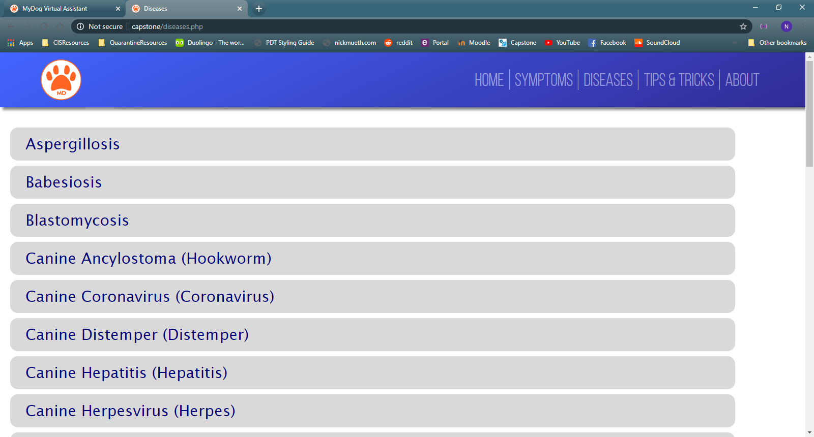

Page conceptualized by Osvaldo Sanchez, Nick Mueth, and Parfait Domagni.

Implemented by Nick Mueth and Parfait Domagni.

This disease page is a list of all potential diseases along with an outline of their main symptoms, which expands upon a click. If clicked again, it will take them to a clicked disease page with more information.

## Clicked Diseases

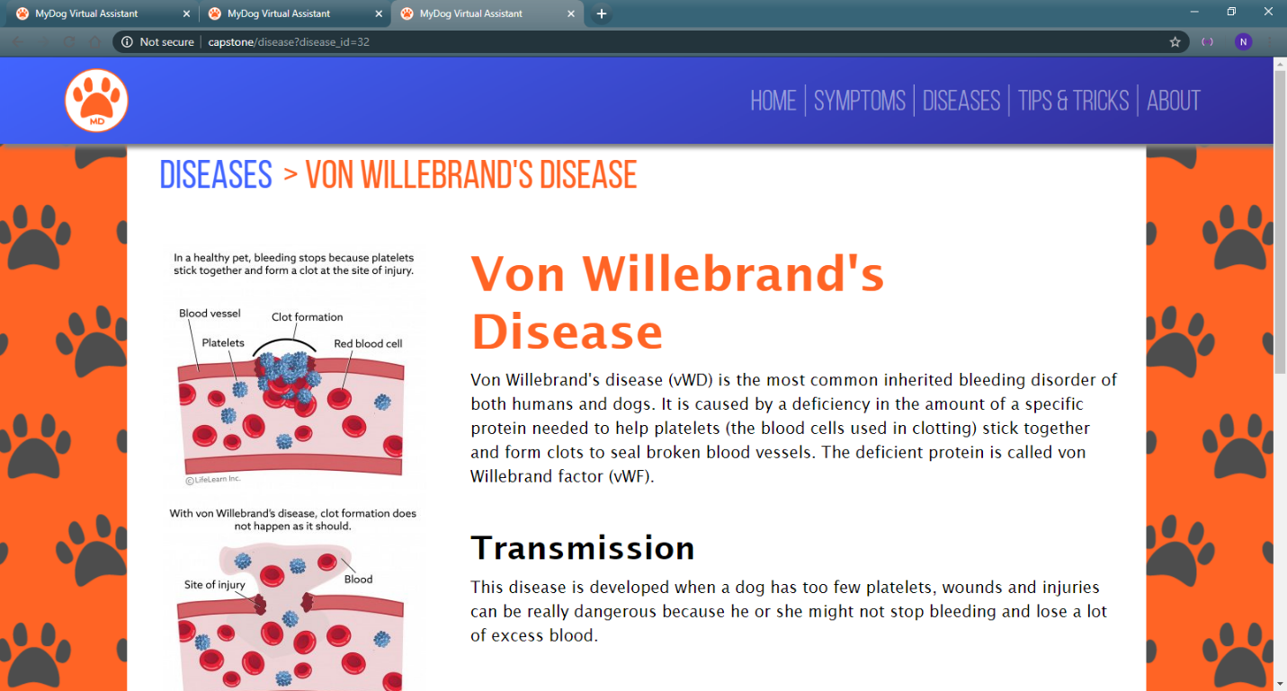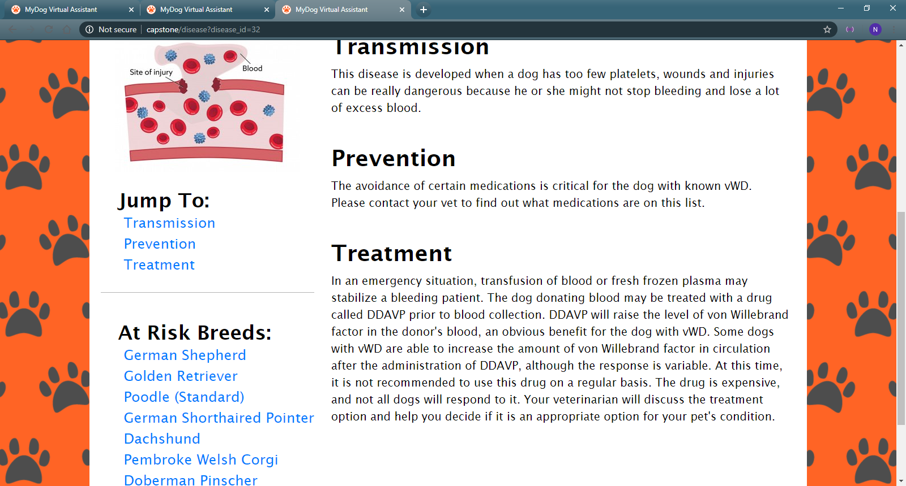

Page conceptualized and implemented by Osvaldo Sanchez

This page will present the user with information about the disease they have clicked through two means, either by clicking on it from the symptoms page predictor or from the diseases page. It presents the user with vital information about their disease along with a descriptive image.

## Tips and Tricks Page

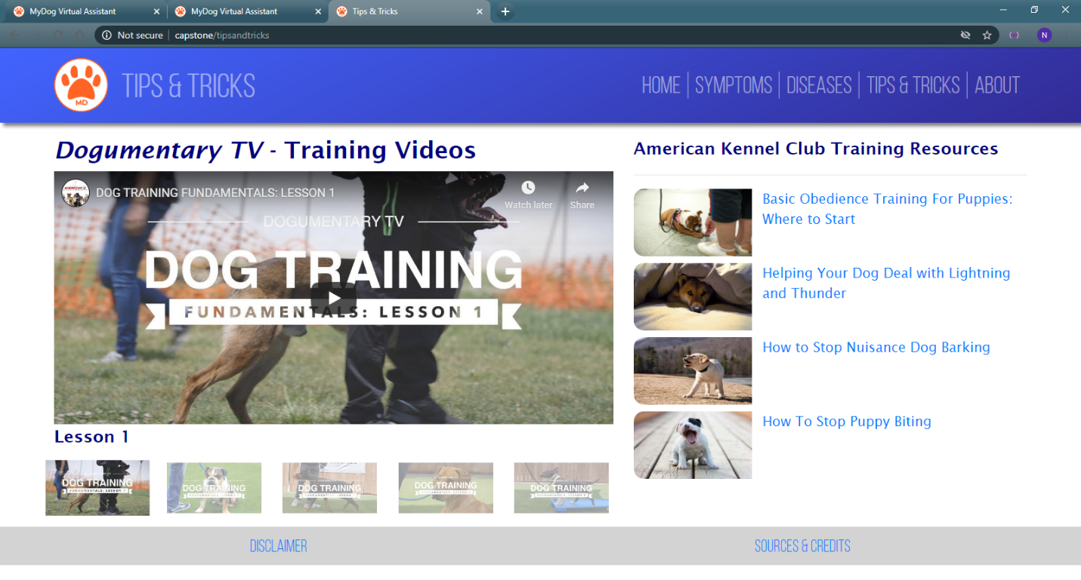

Page conceptualized and implemented by Joshua Toth and Nick Mueth

This page is meant to provide users with useful information about their dog’s health, proper training methods, and general behavior.

## About

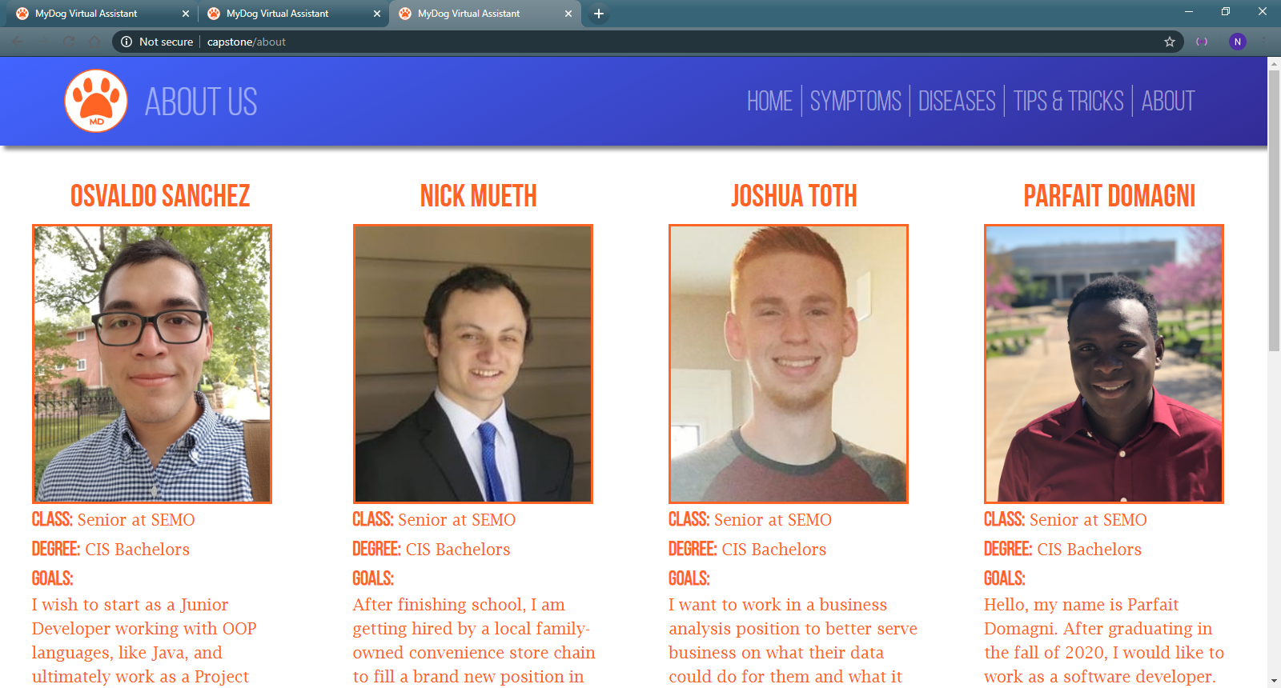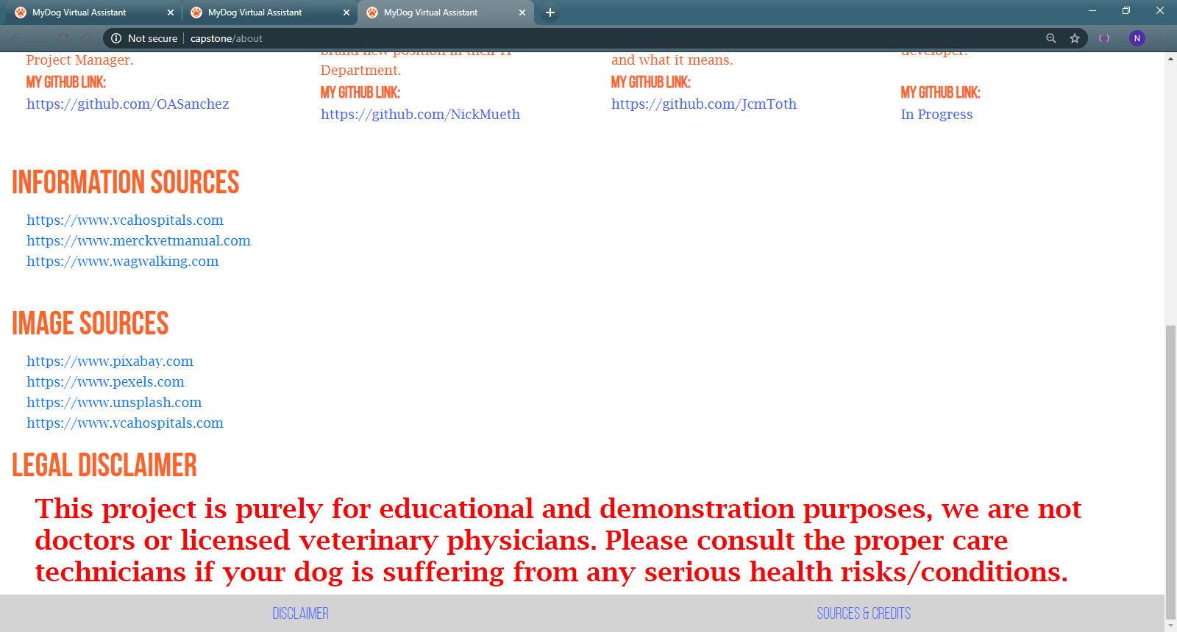

Page conceptualized and implemented by Osvaldo Sanchez.

This is our last page which contains basic information on all group members, sources, and legal disclaimer.

## Database

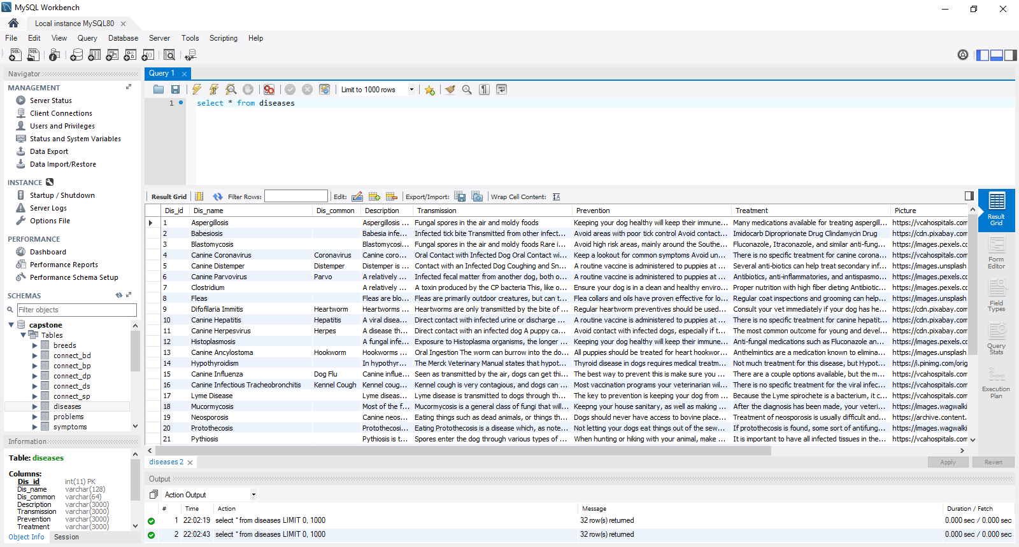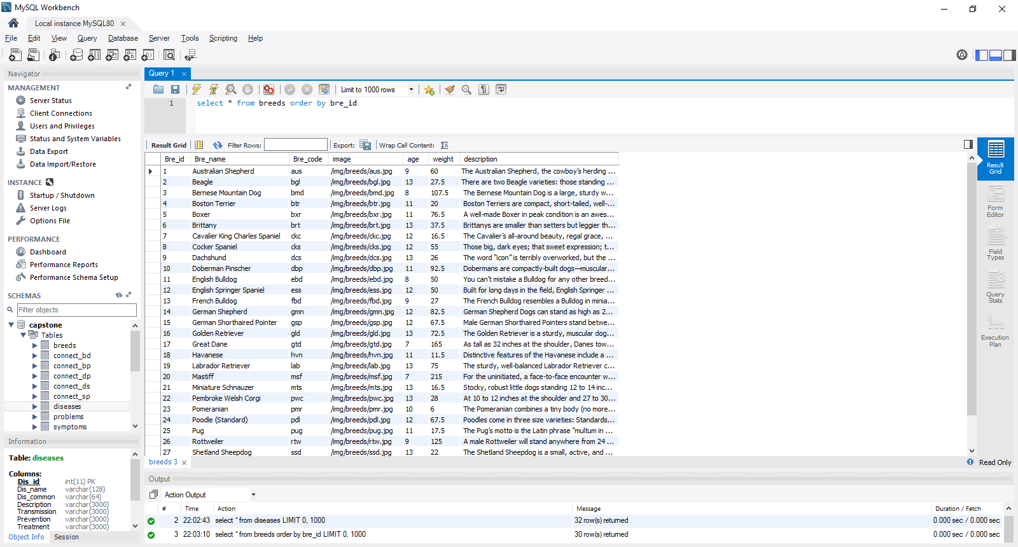

## Conclusion

We are working on creating a virtual assistant for dogs. The main idea behind this project is to make veterinary services more easily accessible in order to help dog-owners and allow customers to enjoy the app. This virtual assistant will be useful for dog owners because they will be able to tell what their dog is suffering from by just answering some questions asked by the app. However, if the virtual assistant cannot help the customer, it will tell him to see a professional for help.

# User Manual

There are multiple ways to navigate our website in order to find the information you need most. In order to find your needs, please refer to relevant section:

## I just got a new dog, could you tell me more about it?

1. Go to the home page of the website
2. Navigate to the breed which looks most like your dog
3. Hover over the image and click it.

## My dog is sick! I know the symptoms, but want to know what could be wrong.

1. Go to the symptoms page using the navigation bar at the top
2. Please select the relevant symptoms your dog has
3. Submit your selections at the bottom
4. On your results page, select which diseases you would like to learn more about, they are sorted from most to least likely.

## I think I know the disease my dog has, but I want to know more about it.

1. To learn more about diseases, first click the disease page.
2. Secondly, click the relevant disease, and you will be taken to the clicked disease page
3. If you would like to know others, navigate using the navigation bar, breadcrumb trail at the top, or the back button on your browser.

## I want to be a better dog owner.

1. To learn more, on the navigation bar at the top, click the Tips & Tricks section
2. From there, you can learn important and basic animal care from curated sites and videos linked

## I want to learn more about this site’s creation.

1. To learn more, on the navigation bar at the top, click the About section
2. Here, you can learn about the contributions, informational sources, and an important disclaimer about our site.

# Administration Manual

Our client instructed us that our product should only run locally. As such, the server must be set up before being able to properly navigate the site. To do so, please follow these instructions:

1. Go to the GitHub link at the bottom
2. Download the master branch
3. Start a PHP and MySQL compatible server, such as WAMP
4. Initialize the MySQL schema in MySQL Workbench through a valid connection and import using the “MyDogDB” file in the “SQL” folder.
5. Change the “connection.php” file in the “Master” folder to coincide with your servername, username, password, and database name in your MySQL connection. An example of that code is below:

    $servername = "localhost:3308";

    $user = "username";

    $pass = "password";

    $db = "database_name";

1. Run the home page, or any page, using the php server at your local host

# Glossary

**About Page-** A page where users can learn more about the developers of the site along with our basic informational sources.

**Breed Page-** A page where users can learn more about their dog’s breed.

**Clicked Disease Page-** The disease on which the user has selected. Informs the user with a description, image, transmission, prevention, and treatment options.

**Connection.php-** A php file that handles the work of connecting to a database to populate pages with information.

**Disease Page-** A page where a user can see a list of all diseases and use it to navigate to the clicked disease page.

**Disease Names:** For any disease in our web app, there are relevant pages which inform the user of what they mean.

**Functional Requirements-** Requirements our system needs in order to perform its operations.

**Home Page-** A page where users can see our main navigation elements, navigate to any of them, or select their breed of dog.

**Navbar-** Our navigation bar which holds our main logo along with links to each of our main pages the users should access.

**Non-functional Requirements-** Requirements we would like our system to accomplish and adhere to, but are not required for operation.

**Results Page-** A page where users can see their results from the symptoms page and click on relevant diseases.

**Symptom-** A negative condition their dog is facing, most likely due to disease.

**Symptoms Page-** A page where users can select a variety of symptoms which may be ailing their dog.

**Tips and Tricks Page-** A page where users can see useful information for being a better pet owner.

# Conclusion

Thank you for taking the time to read through our documentation for the MyDog Virtual Assistant. It is a project which has been built from the ground up with users in mind, first and foremost. As it is now, we feel we have created a very high-quality product that is sure to appeal to users and satisfy their needs indefinitely. However, that does not mean the site is completed.

From now on, all contributing members have the creative license to style the site however they deem fit and to edit the underlying code of our contributions. The only stipulation is that the contributions on the original pages must remain the same, so everyone is still credited for their works in the future. Clarifying that further customization has been done is allowed.

# Appendix A – Client Acceptance Form:

**Project Completion**

**Final Client Acceptance Form**

**Purpose of form:**  The purpose of this form is for the client to provide final acceptance of all aspects of the completed project package that has been delivered to them by the developer team.

**Project Name:** MyDog Virtual Assistant

**Project description:** A virtual assistant aimed at helping dog owners diagnose the most common illnesses found in their dogs. Along with this, dog owners are also able to learn about their breeds and general dog care.

**Project Contact information and identification**

**Developer Contact Details**

**Developer(s)’ Manager/Agency:** Osvaldo Sanchez

**Developer(s)’ name(s) email(s) and phone number(s):**

Osvaldo Sanchez – osvsanchez1@gmail.com – (573)-344-0966

Joshua Toth – jcmtoth@gmail.com– (636)-7347117

Nick Mueth – nickmueth@gmail.com – (618)-806-0297

Parfait Domagni – pdomagni1s@semo.edu

**Client Contact Details**

**Client(s)’ Manager/Agency:** Southeast Missouri State University

**Client(s)’ name(s) email(s) and phone number(s):**

Dr. Suhair Amer – samer@semo.edu – (573)-651-2525

**Client Signature:** _________________________________________ **Date:** 04/30/2020

# Appendix B – Interfaces and Code Snippets:

## Interfaces

Home Page Interface****

## Symptoms Page Interface



## Results Page Interface



## Disease Page Interface



## Tips and Tricks Page Interface



## Code Snippets

<?php

symptomCheck();

uasort($results, function($a, $b){

return $b[1] <=> $a[1];

});

echo '<table><tr><th id="diseaseCol">Disease</th><th id="chanceCol">Chances</th></tr>';

foreach($results as $rows){

if($rows[1]>=75){

echo '<tr class="bg-danger dis" style="font-size:1.5rem;"><td><a style="color:white;" href="disease.php?disease_id='.$rows[0].'">'.$rows[0].'</a></td><td>'.$rows[1].'% chance</td></tr>';

} elseif ($rows[1]>=50) {

echo '<tr class="bg-warning dis" style="font-size:1.25rem;"><td><a style="color:white;" href="disease.php?disease_id='.$rows[0].'">'.$rows[0].'</a></td><td>'.$rows[1].'% chance</td></tr>';

} elseif($rows[1]>=30){

echo '<tr class="dis" style="font-size:1rem;"><td><a href="disease.php?disease_id='.$rows[0].'">'.$rows[0].'</a></td><td>'.$rows[1].'% chance</td></tr>';

} elseif($rows[1]>=15){

echo '<tr style="font-size:0.75rem;" class="dis"><td><a href="disease.php?disease_id='.$rows[0].'">'.$rows[0].'</a></td><td>'.$rows[1].'% chance</td></tr>';

}else{

echo "<tr><td></td><td></td></tr>";

}

}

echo '</table>';

?>

results page display

**RESULTS PAGE DISPLAY**

======Some More Results Page Functions========**

//FUNCTIONS

function weightCheck(){

//check weight dangers for dogs like dachshunds

global $weight, $max_wgt, $min_wgt, $bre_name;

if($weight>$max_wgt){

echo '<h3 class="bg-danger" style="color:white; padding:10px; border-radius:10px;">Your dog weighs '.$weight.' lbs! They may be suffering from obesity!<small> - A healthy weight for your dog is between '.$min_wgt. ' and '.$max_wgt.' lbs</small>';

if($bre_name=="Dachshund"){

echo '<br><strong>YOUR DOG'S BREED ('.$bre_name.') CAN SUFFER SERIOUS DAMAGE FROM OBESITY! Go visit the vet ASAP!</strong>';

}

echo '</h3>';

}

else if($weight>=$min_wgt && $weight<=$max_wgt){

echo '<h3 class="bg-success" style="color:white; padding:10px; border-radius:10px;">Your dog weighs '.$weight.' lbs! They are a healthy weight, keep it up!</h2>';

}

else{

echo '<h3 class="bg-warning" style="color:white; padding:10px; border-radius:10px;">Your dog weighs '.$weight.' lbs! They may be underweight!<small> - A healthy weight for your dog is between '.$min_wgt. ' and '.$max_wgt.' lbs</small></h3>';

}

}

function VonWillebrandSeverityCheck(){

//check if based on breed, dog has a more severe case of von willebrand

global $bre_id;

//Shetland Sheepdog (27)

if($bre_id==27){

return 1;

}

//German Shorthaired Pointers (15)

elseif($bre_id == 15){

return 2;

}

//Bernese (3), Dachshunds (9), Dobermans (10), German Shepherds (14), Golden Retrievers (16), Corgis (22), Poodles (24)

elseif ($bre_id == 9 $bre_id == 3 $bre_id == 10 $bre_id == 14 $bre_id == 22 $bre_id == 24 $bre_id == 16) {

return 3;

}

else{

return 0;

}

}

idk why but it did spoilers stuff

function createNewRow($area_row){

echo '<div class="row area_row">';

foreach($area_row as $area){

echo '<div class="collapsible symptom_category multi-grad col"><h4>' . ucfirst($area) . '</h4></div>';

}

echo '</div>';

}

function createSymptomRows($symptoms){

$temp_row = null;

echo '<div>';

foreach($symptoms as $sym_row){

if($temp_row[0] != $sym_row[0]){

$temp_row=$sym_row;

echo '</div><div class="row symptoms" id="' . ucfirst($sym_row[0]) . '">';

echo '<div class="col-4 symptom"><label class="checkmark-label">';

echo '<input type="checkbox" name="symptoms[]" value="' . $sym_row[1] . '"><span class="checkmark"></span></input>' . $sym_row[1] . '</label>';

echo '</div>';

} else{

echo '<div class="col-4 symptom"><label class="checkmark-label">';

echo '<input type="checkbox" name="symptoms[]" value="' . $sym_row[1] . '"><span class="checkmark"></span></input>' . $sym_row[1] . '</label>';

echo '</div>';

}

}

echo '</div>';

}

CreateNewRow and CreateSymptomRow for layouts for the symptoms page categoryies

Your Code for the Diseases Pages

<div class="grid-container">

<div class="gImage">

<!-- IMAGE OF CLICKED DISEASE, CURRENTLY JUST A HARDCODED PLACEHOLDER -->

<div class="dContainer">

<img class="clicked-image" src="<?php echo $picture; ?>" alt="<?php echo $reference; ?>">

</div>

</div>

<div class="gDisease">

<h1><?php echo $dis_name; if($dis_common!=null){ echo '<br><small>(' . $dis_common . ')</small>';}?></h1>

<p><?php echo $description; ?></p>

</div>

<?php

if($connect_bd->num_rows > 0){

echo '<div class="gRiskList"><h2>At Risk Breeds</h2>';

echo '<ul>';

while($row = $connect_bd->fetch_assoc()){

$bre_id = $row["Bre_id"];

$bre_name = $row["Bre_name"];

echo '<li><a href="breed.php?breed_id=' . $bre_id . '">' . $bre_name . '</a></li>';

}

echo '</ul></div>';

}

?>

<div class="gTransmission">

<h2> Transmission </h2>

<p><?php echo $transmission; ?></p>

</div>

<div class="gPrevention">

<h2> Prevention </h2>

<p><?php echo $prevention; ?></p>

</div>

<div class="gTreatment">

<h1> Treatment </h1>

<p><?php echo $treatment; ?></p>

</div>

<br>

</div>

# Appendix C - Communication:

Most of our communication has been physical, as all group members are able to meet on Tuesdays and Thursdays before our CS 300 class which we all share. We have established a common time of 9am on those days and whoever is able to work on the project to do so after the class. As a result, there is not a lot of documented communication from the beginning stages of the project. During the Coronavirus Pandemic, we have mostly used verbal communication through discord.

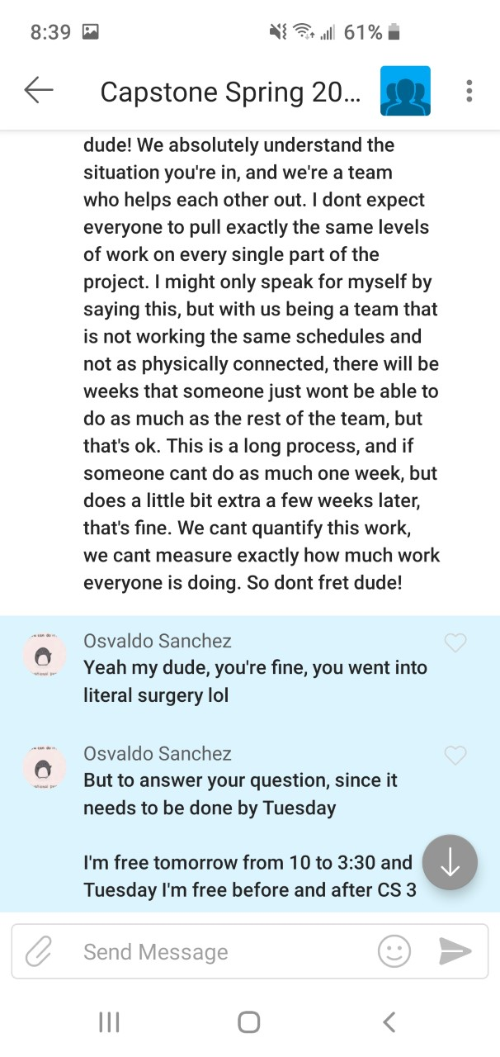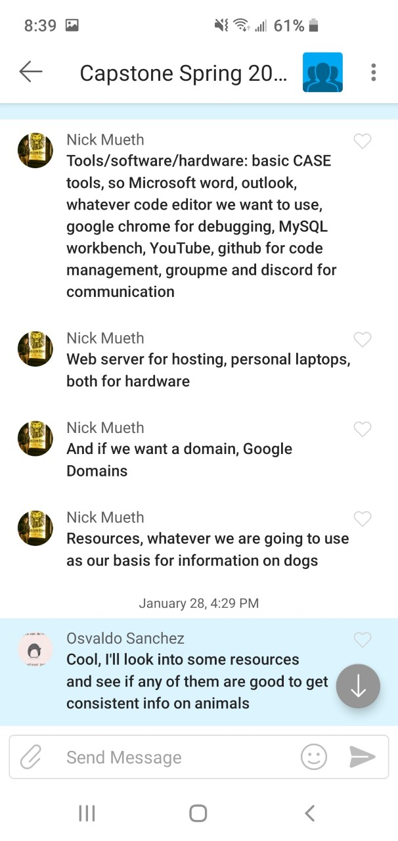

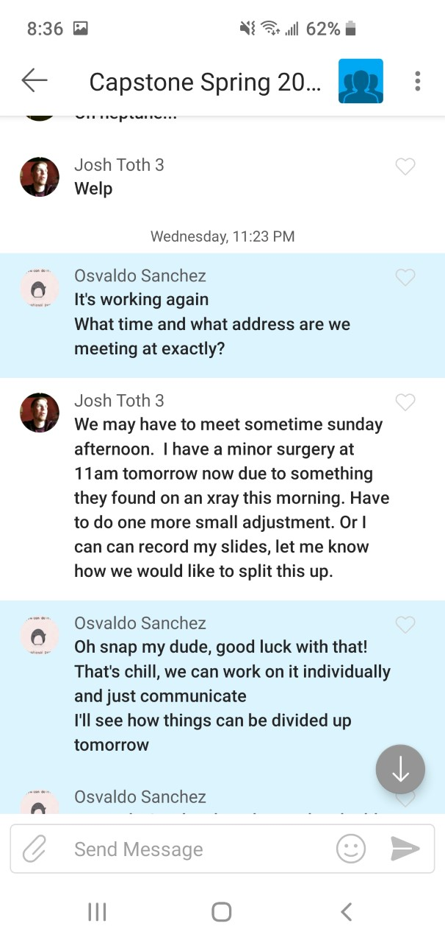 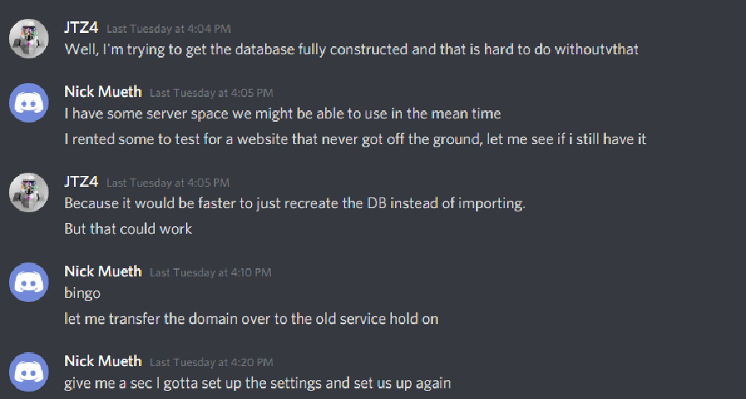

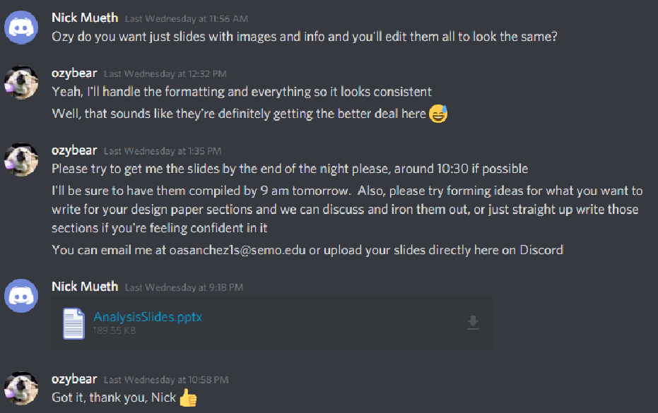

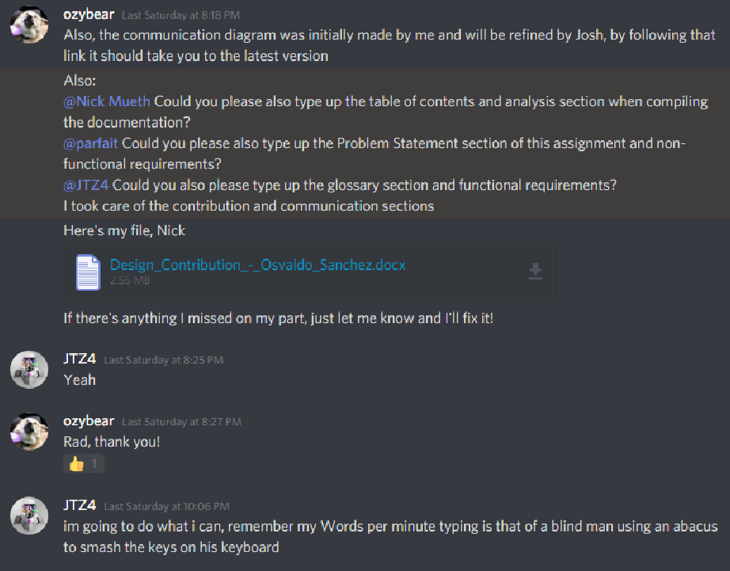

# Contribution List

## Osvaldo Sanchez

Problem Statement, Scenarios, Contribution List, Communication Correspondence, Distribution of Tasks, Component Diagrams, Communication Diagrams, Design Goals, Interface Specifications, Restructuring to manipulate the system model, Refinement of Reports, Appendix A, B, C, Clicked Disease Page, About Page, File Management, Team Organization, Code Cleanup

## Joshua Toth

Working on Database for project and generating appropriate diagrams for analysis, Component Diagrams, Class Diagram, Identifying Persistent Data, Communication Diagrams, Functional Requirements, Tips and Tricks Page, Code Cleanup

## Nick Mueth

Table of Contents, Assumptions, Functional Requirements, Business Model, and Compilation of Documents, Performance Criteria, Deployment Diagram, Global Control Flow, Home Page, Breed Page, Symptoms Page, Tips and Tricks Page

## Parfait Domagni

Nonfunctional Requirements, Analysis Requirements Deemed Appropriate, Conclusion, Identifying Services, Identifying off-the-shelf components, Problem Statement, Report Overview and Refinement

# Files

All of our files can be found on our main GitHub Repository:

<https://github.com/NickMueth/CapstoneSpring2020>